DEVELOP AN LTE-M COMMUNICATION WORKFLOW FOR WEARABLE MONITORING SYSTEMS.

CODE:
clc;
clear;
close all;
%% LTE-M Wearable Monitoring System
% Simulation Parameters
SNR_dB = 0:2:20;
BER = zeros(length(SNR_dB),1);
PDR = zeros(length(SNR_dB),1);
Reliability = zeros(length(SNR_dB),1);
%% Wearable Sensor Data
HeartRate = randi([60 100],100,1); % Heart Rate (bpm)
Temperature = 36 + rand(100,1)*2; % Temperature (36-38°C)
disp('Sample Heart Rate Data');
disp(HeartRate(1:10));
disp('Sample Temperature Data');
disp(Temperature(1:10));
%% Convert Sensor Data to Binary
% Convert temperature to integer (36.5 -> 365)
TempInt = round(Temperature * 10);
% Merge sensor values
sensorData = [HeartRate; TempInt];
% Calculate required number of bits automatically
numBits = ceil(log2(max(sensorData)+1));
% Convert decimal to binary
binaryData = dec2bin(sensorData, numBits) - '0';
% Convert matrix to serial bit stream
txBits = binaryData(:);
%% Simulation
for k = 1:length(SNR_dB)
snr = SNR_dB(k);
%% BPSK Modulation
txSignal = 2*txBits - 1;
%% AWGN Channel
rxSignal = awgn(txSignal, snr, 'measured');
%% Receiver
rxBits = rxSignal > 0;
%% BER Calculation
numErr = sum(txBits ~= rxBits);
BER(k) = numErr / length(txBits);
%% Packet Delivery Ratio
packetSize = 64;
packets = floor(length(txBits)/packetSize);
success = 0;
for p = 1:packets
idx1 = (p-1)*packetSize + 1;
idx2 = p*packetSize;
if isequal(txBits(idx1:idx2), rxBits(idx1:idx2))
success = success + 1;
end
end
PDR(k) = success / packets;
%% Reliability
Reliability(k) = (1 - BER(k)) * 100;
end
%% BER Plot
figure;
semilogy(SNR_dB, BER, '-o','LineWidth',2);
grid on;
xlabel('SNR (dB)');
ylabel('Bit Error Rate (BER)');
title('BER Performance of LTE-M Wearable Monitoring');
%% PDR Plot
figure;
plot(SNR_dB, PDR,'-s','LineWidth',2);
grid on;
xlabel('SNR (dB)');
ylabel('Packet Delivery Ratio');
title('Packet Delivery Ratio');
%% Reliability Plot
figure;
plot(SNR_dB, Reliability,'-d','LineWidth',2);
grid on;
xlabel('SNR (dB)');
ylabel('Reliability (%)');
title('Communication Reliability');
%% Display Results
Results = table(SNR_dB', BER, PDR, Reliability,...
'VariableNames',{'SNR_dB','BER','PDR','Reliability'});
disp('Simulation Results');
disp(Results);

OUTPUT:
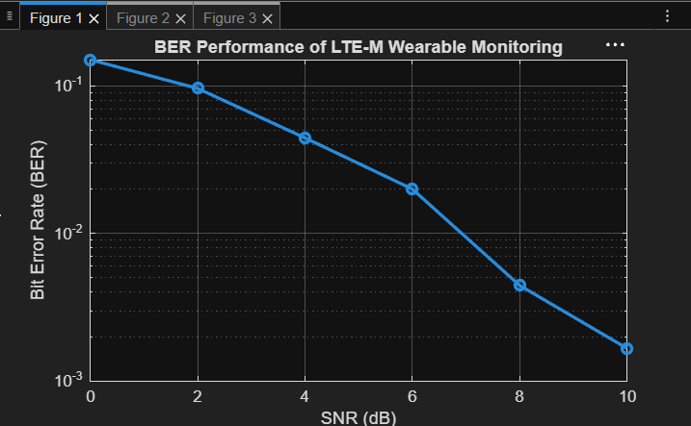
Fig.1

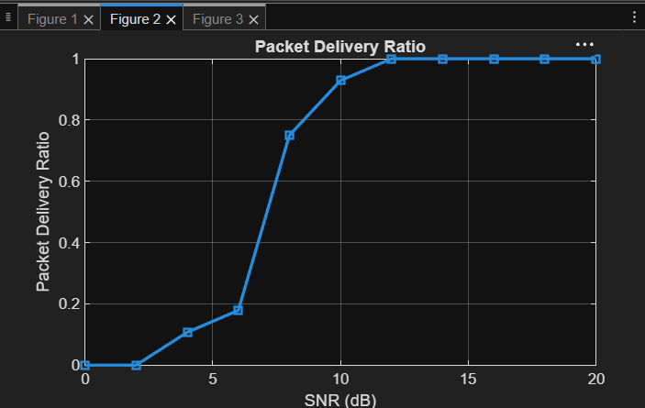
Fig.2

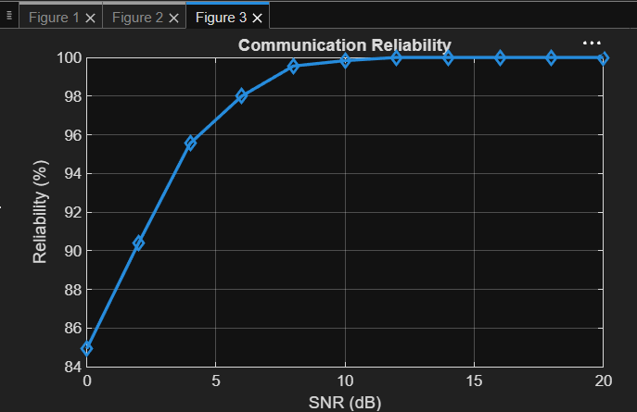
Fig.3

